Activities:

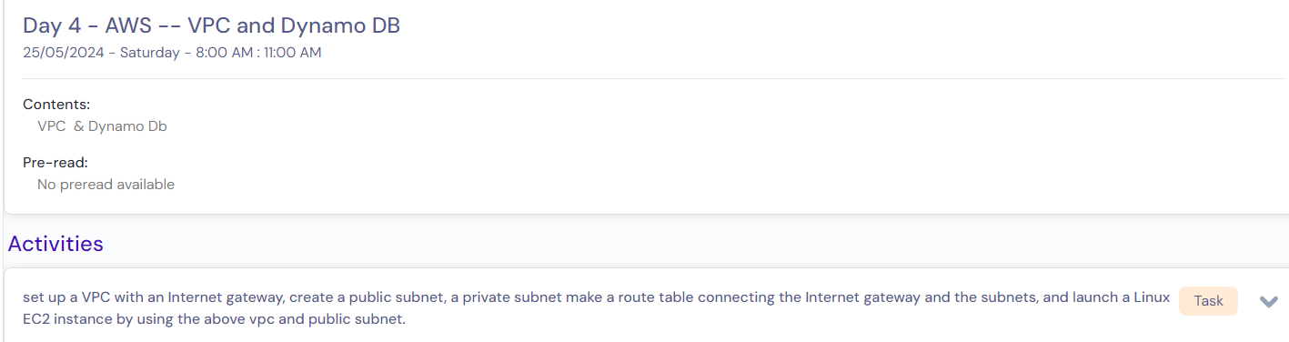

# Pre-requisite:

1. Login to AWS console.
2. Choose the desired region in which we want to create our VPC.

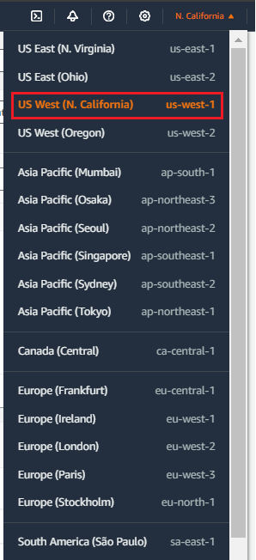

# **set up a VPC with an Internet gateway.**

1. Search “vpc” and click on “VPC” as shown below.

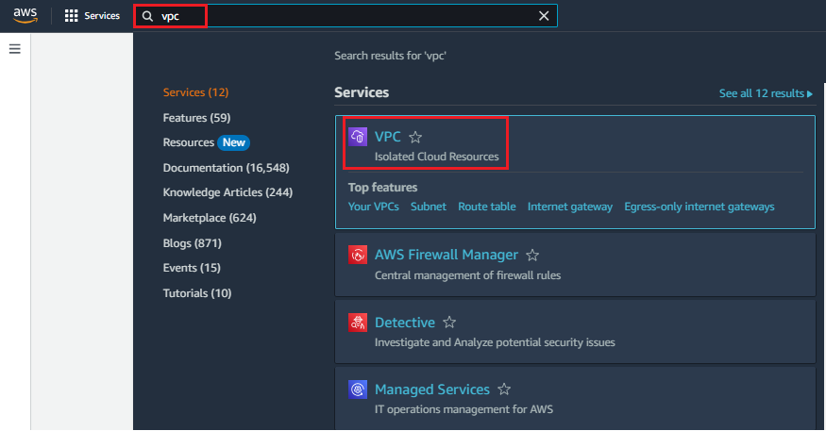

1. Click on “**your VPCs**” at left side navigation under “Virtual private cloud.” as shown below and click on “**create vpc**” to create a virtual isolated network environment.

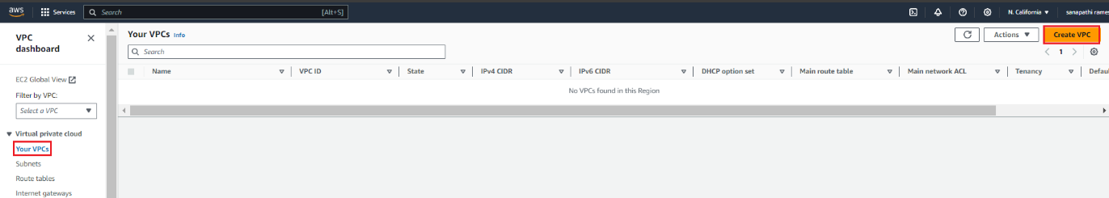

1. Choose VPC settings as below as an example and click on “**create vpc**”.

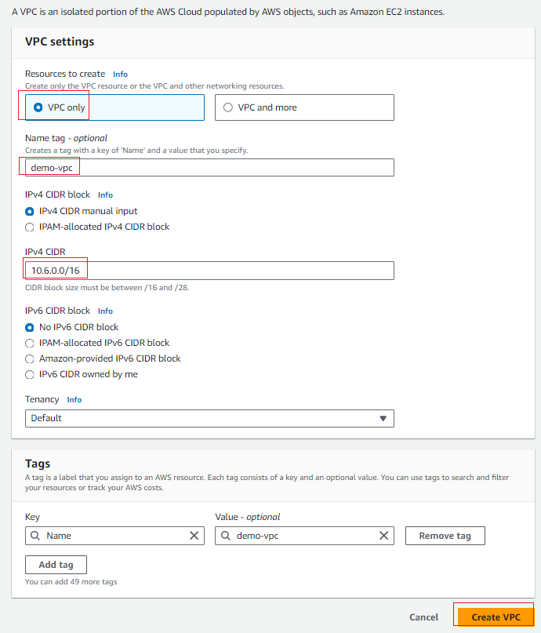

1. The below image gets displayed if it is created successfully.

1. Click on “**Your VPCs**” at left side navigation under “**Virtual private cloud**” to view or list the current available VPC’s.

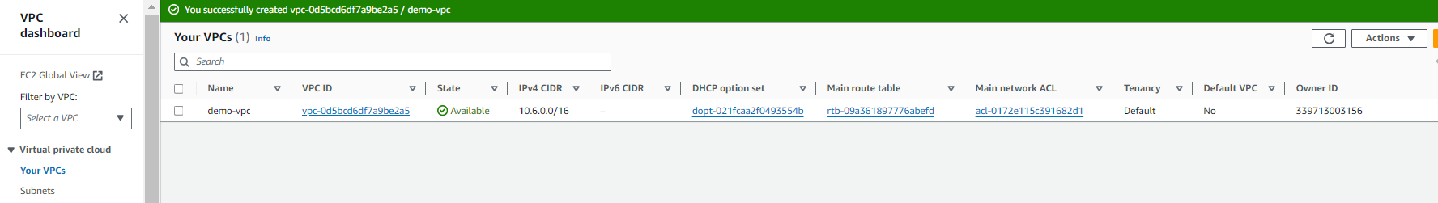

1. Choose “**Internet Gateways**” at left side navigation under “**Virtual private cloud**” and click on “**Internet Gateway**.”

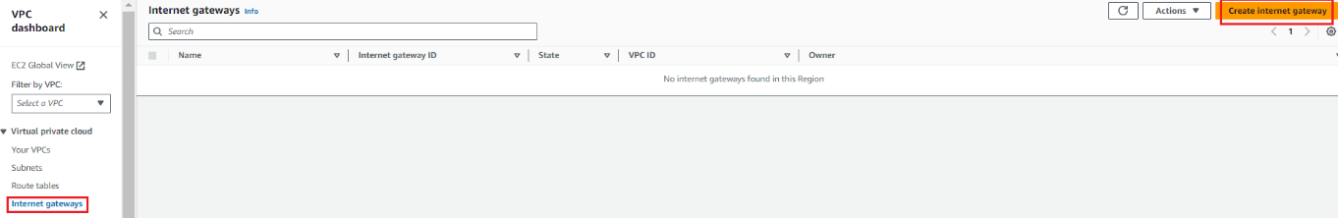

1. Enter name and click on “**create internet gateway**.”

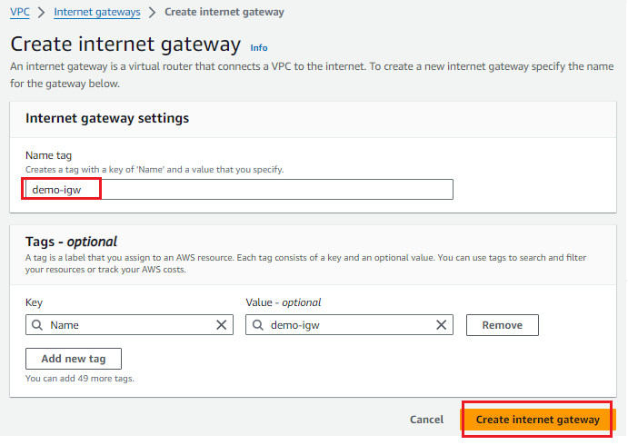

1. internet gateway has been created successfully with state = **Deatched**.

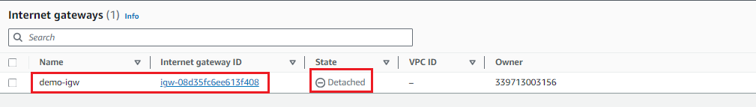

1. choose “**demo-igw**” and click on “**Actions**” and select “**Attach to VPC**”.

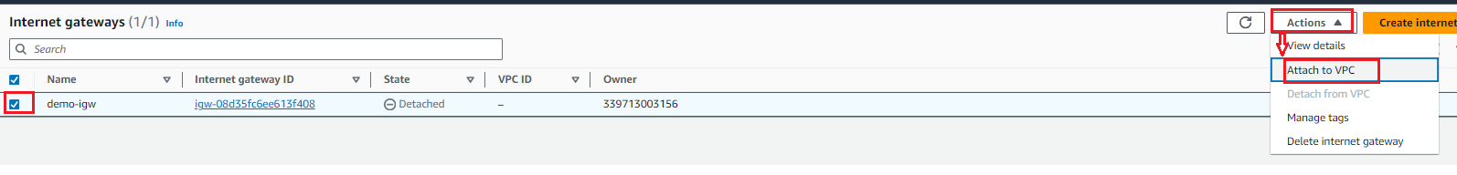

1. choose “**demo-vpc**” under “Available VPCs” and click on “Attach internet gateway”.

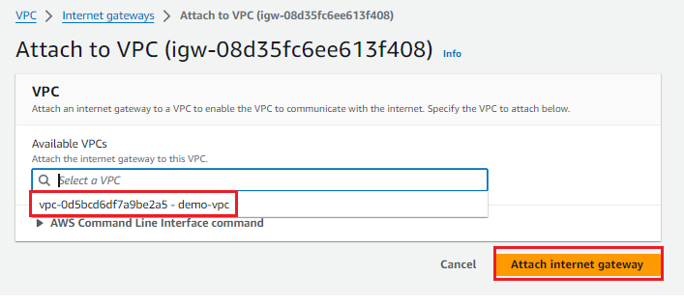

1. make sure, internet gateway “demo-igw” state should be “**Attached**.”

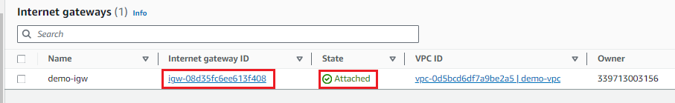

# **create a public subnet.**

1. Choose “**Subnets**” at left side navigation under “**Virtual private cloud**” and click on “**create subnet**.”

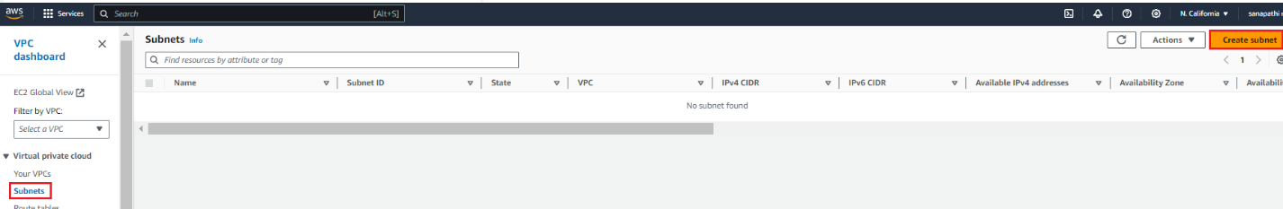

1. choose data for all required fields and click on “**create subnet**.”

In this example, I have created a public subnet with **10.6.1.0/24.**

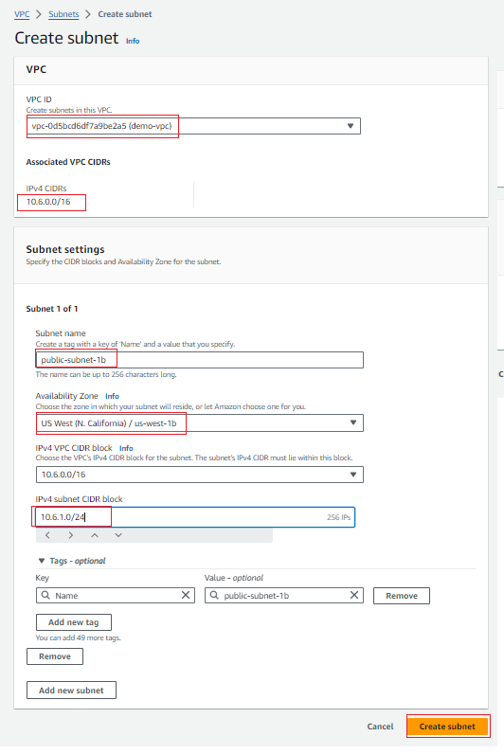

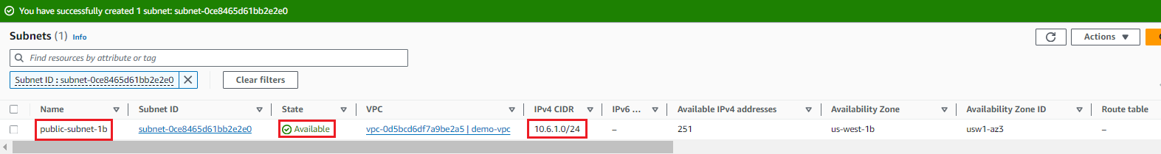

# **create a private subnet.**

1. Click on “**create subnet**” to create a **private subnet** with ip subnet range as **10.6.2.0/24** as example.

**Note:** make sure, IP subnet range should be part of VPC IP network range.

1. choose data for all required fields and click on “**create subnet**.”

In this example, I have created a private subnet with **10.6.2.0/24.**

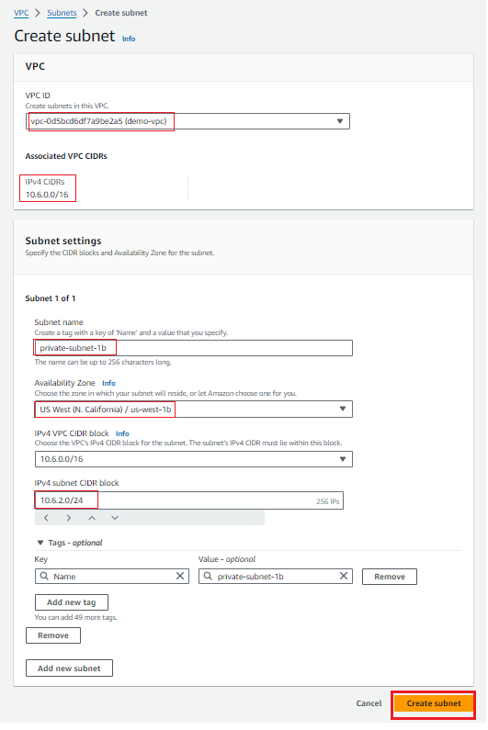

1. As shown below, private subnet has been created successfully with IP range: **10.6.2.0/24.**

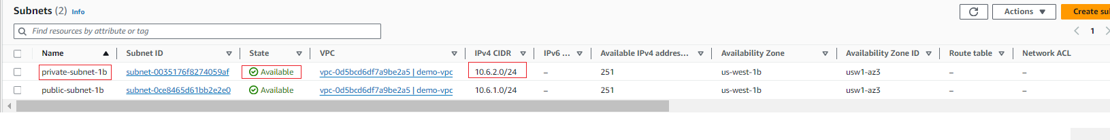

1. By now, I have created both public subnet and private subnet as shown below.

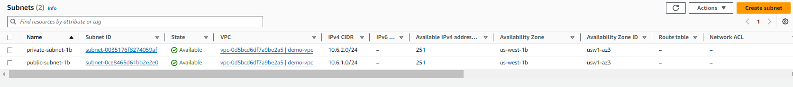

# **make a route table connecting the Internet gateway and the subnets.**

1. Choose “**route table**” at left side navigation under “**Virtual private cloud**”.
2. Route table Info gets displayed which has been created during VPC creation.

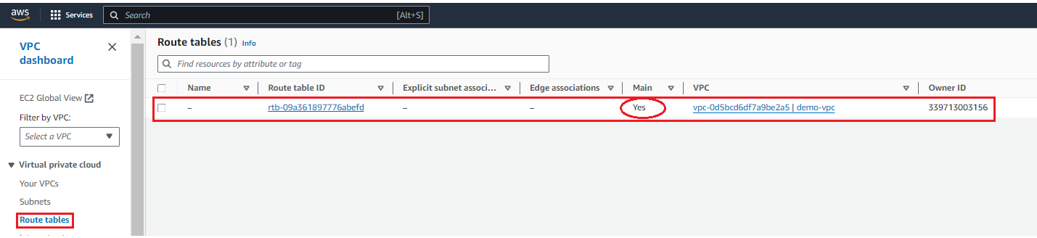

,

1. Select **route table** and go to “**Routes**” Tab and click on “**Edit routes**” as shown below.

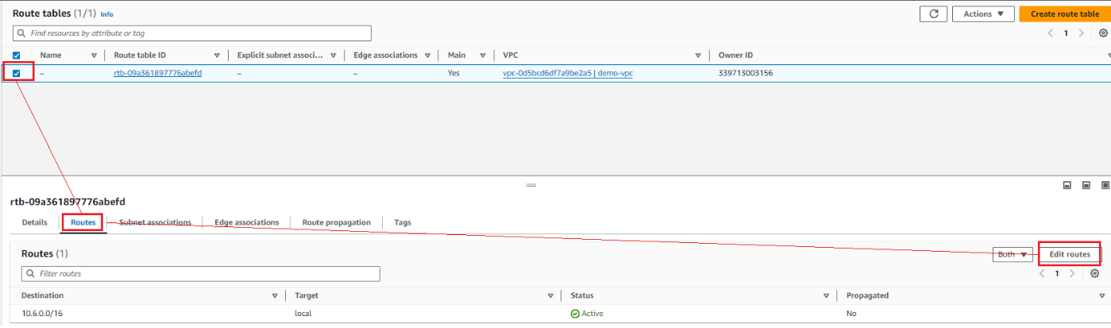

1. Click on “**Add route**” to fill **destination**, **target as internet gateway** and click on “**Save changes**”.

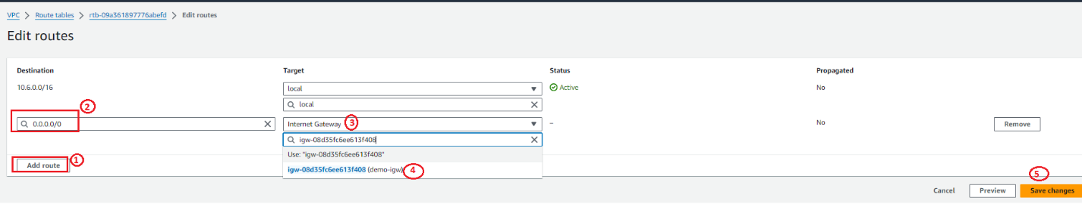

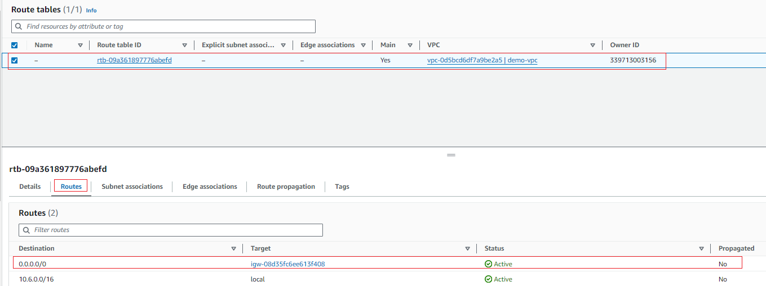

1. Select the same route table and go to “subnet associations.” as shown below.

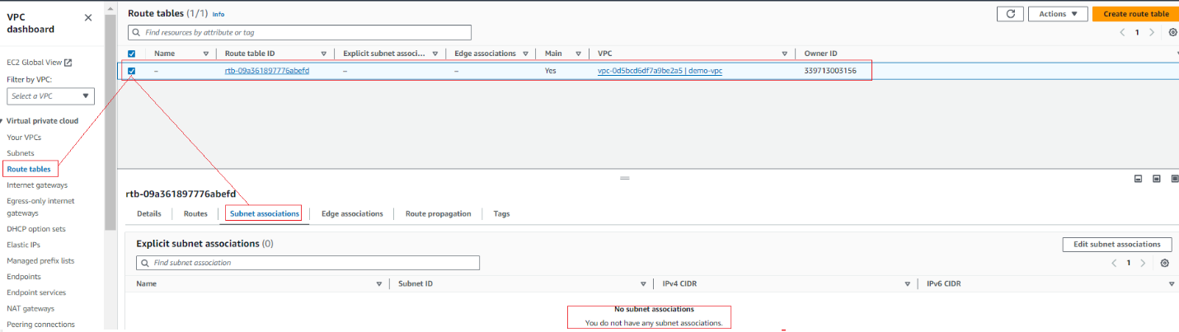

1. Click on “**Edit subnet associations”** and choose **public subnet** and click on “**Save associations**.”

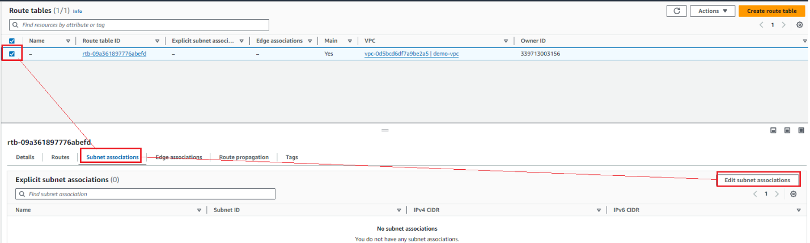

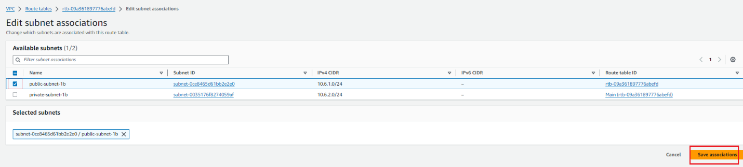

Note: we need to associate public subnet with internet gateway to make sure public subnet ec2 instance is accessible from anywhere in the world.

# **launch a Linux EC2 instance by using the above vpc and public subnet.**

1. Go to Instance Dashboard and click on “**Launch instances**”.

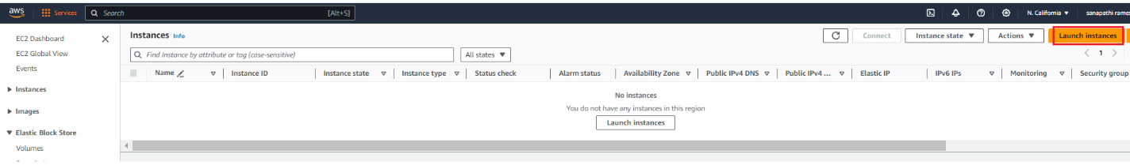

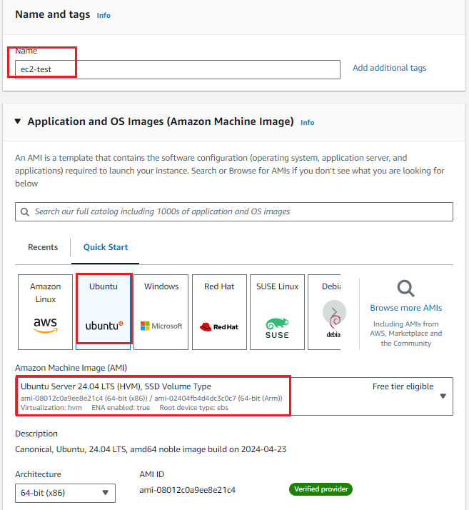

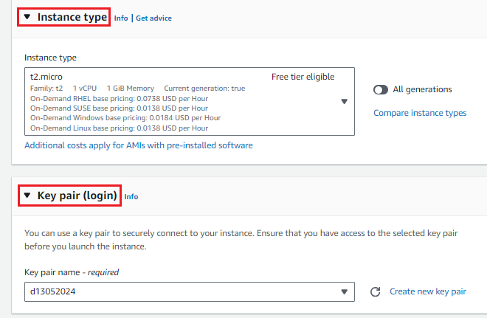

In the network settings, we must select correct **VPC and public-subnet, Auto-assign public IP = Enable**.

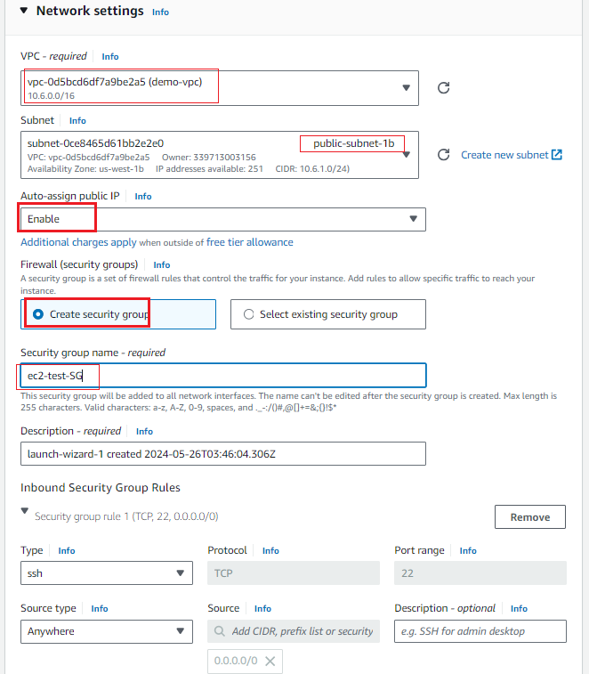

Finally, click on **launch instance** to create an instance.

Select an instance to view the instance details. As shown below, instance state is **running,** and status check is **2/2 check passed**.

Also, make sure that instance **private IPv4 address** is allocated from public subnet range i.e. **10.6.1.0/24.**

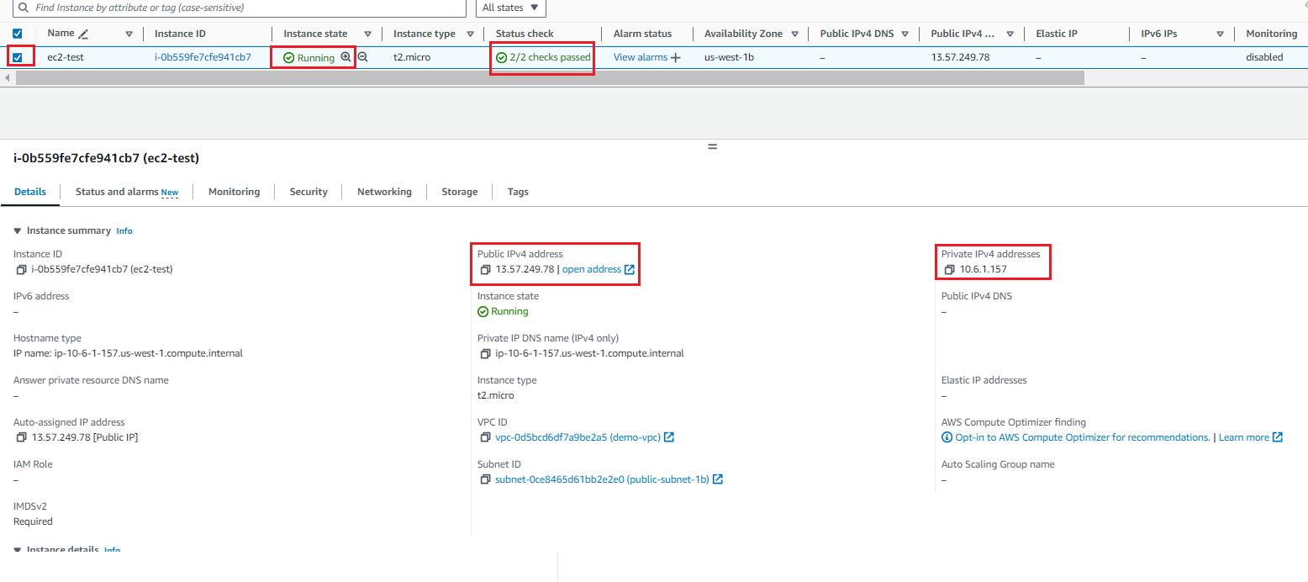

# **Verification:**

Login to EC2 instance with public ip address.

Run “ssh -i d13052024.pem [ubuntu@13.57.249.78](mailto:ubuntu@13.57.249.78)” from private key available path to connect to EC2 instance.

